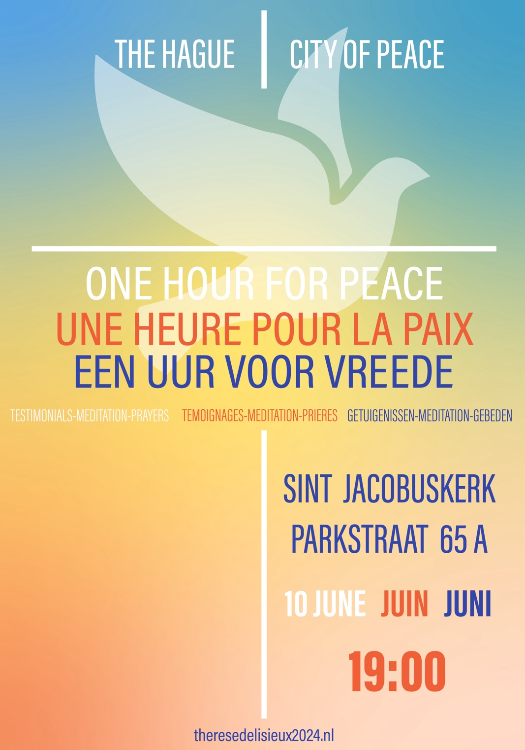
ENGLISH

WELCOME

PRESENTATION by Father Marc LEROY and Father Justin MWENDAKULALA

THE HARMONY OF JUSTICE AND PEACE

INTRODUCTION by Bishop van den HENDE,

Bishop of Rotterdam
- Prayer of de Saint Francis- Choir AVE
1 - Là où il y a la haine, Que surgisse ton amour,
Là où il y a le doute, Que s'élève un chant de foi !

Que ton règne vienne Comme l'aube sur la nuit !
Que ton règne vienne, Qu'il éclaire et change notre vie !

2 - Là où règnent les ténèbres, Que paraisse ta clarté.
Là où cesse l'espérance, Que s'élève un chant d'espoir !

3 - Là où naissent les discordes, Que s'installe l'unité,
Là où il y a la guerre, Que s'élève un chant de paix !

4 - Là où il y a l'offense, Que s'éveille le pardon,
Là où règne la tristesse, Que s'élève un chant de joie !

5 - Là où règne le mensonge, Fais fleurir la vérité,
Là où siège l'injustice, Que s'élève un chant d'amour !

THE HAGUE, CITY OF PEACE - Pepijn ZAAGMAN,

Representative of the Mayor.

Suite for cello N°1 en G maj, BMW 1007, J.S. BACH – Sylvain DESSANE

Message from the permanent court of arbitration

Marcin CZEPELAK

WHAT HAVE YOU DONE TO YOUR BROTHER?

CRY OF THE HEART
By a group of the young

TESTIMONY - Gaëlle BÜHLER
I have already had many people from older generations tell me: "I wouldn't want to be in your generation, with all the problems our world currently has and those that are looming for our future...". Each time, I wonder what the point is of saying that to us.
I partly agree in the sense that our societies are facing colossal problems.
Whether it's the armed conflicts around the world, which cause thousands of innocent people to suffer, taking away a loved one, forcing them to leave their cities, their countries, sometimes even their families behind, or depriving them of food and basic necessities. I am particularly thinking of the war in Ukraine, in Palestine, but also the conflict in the DRC which, for several years, has been causing devastation and is often forgotten. Where is the peace in these atrocities? Where is the message of love that God has transmitted to us?
Climate change is also a worrying phenomenon, which is increasing every day and causing serious natural disasters more frequently. I think, for example, of the floods in Brazil due to torrential rains, but also the melting of glaciers and the resulting rise in sea levels, which, in the years to come, will cause climate refugees if nothing is done.
Extreme overconsumption, which has mainly affected Western countries for several years now, is also an aspect that makes me question things. Making people in developing countries work under inhumane conditions so that we here can buy a T-shirt for 10 Euros. Where is the respect for individuals? Have we forgotten that we are all the same, created in the image of God?
Despite all these serious problems, I refuse to fall into pessimism and anxiety. Yes, there are problems, which are among other things caused by previous generations, but which generation hasn’t had them. That is why I find it inappropriate to make comments about not wanting to be in our generation because we have problems to solve. Instead of indirectly discouraging us, it's better to take action, show courage, and set an example.
So, indeed, my generation is currently facing heavy issues that will need to be resolved to make our planet a world of peace, love, and equity. But we quickly forget that our daily lives are also made up of moments of joy, prayer, perseverance to achieve a personal goal, supporting others, and creativity. By taking the right behaviors and qualities of everyone as help, I remain hopeful that we will manage to turn our planet in a direction that suits us and does not kill it slowly. Maybe we won’t quite succeed, but at least we will have tried, we will have given our body and soul. Often we ask ourselves "What can I do to make a difference?" Upon reflection, however, we can recognize that many major issues also exist in our daily lives. Each of us has the power to change things towards a more peaceful, sustainable, and respectful world. For some, acting might mean spreading the message of God, for others, collecting trash from the sea, or representing their country in international organizations. The only thing we need is the courage to start.

ALLELUIAH, Leonard COHEN- chorale HOSANNAH
1. Pour notre terre hospitalière  Et pour nos mères si nourricières  Je chante la gloire du Seigneur  Pour les rivières et pour les fleuves  Et pour le vent et les embruns  Je chante Allé Alléluia  R. Alléluia ! Alléluia ! Alléluia ! Alléluia !  2. Et pour l’automne et le printemps  Et pour l’été et pour l’hiver  Je chante la gloire du Seigneur  Et pour la neige et pour la pluie  Et pour le givre et la rosée  Je chante Allé Alléluia | 3. Et pour les champs et les forêts  Pour les vendanges et les moissons  Je chante la gloire du Seigneur  Pour les oiseaux et les troupeaux  Pour chaque jour et chaque nuit  Je chante Allé Alléluia  4. Pour le soleil et pour la lune  Pour les nuages et le ciel bleu  Nous chantons la gloire du Seigneur  Pour les montagnes et les sommets  Et pour les plaines et les vallées  Nous chantons Allé Alléluia  5. Pour les enfants et les vieillards  Pour le sourire et la tendresse  Nous chantons la gloire du Seigneur  Pour l’espérance et pour la paix  Pour le pardon et pour l’amour  Nous chantons Allé Alléluia

TESTIMONY ON UKRAINE - P. Oleh ZYMAK
Dear participants in the meeting "An Hour for Peace",
First of all, I would like to thank you for your invitation and apologize for my inability to attend in person.
I thank you for the attention you give to the challenges the world is facing today, and I thank you in particular for the empathy you show towards the victims of a new human tragedy in Europe - the Russian attack on Ukraine. This is a kind of "biblical battle between David and Goliath" in the 21st century.
With this brief contribution, I do not intend to tell you something unknown. As a simple Belgian-Ukrainian Redemptorist priest, I am just a drop in the ocean of many others: Ukrainians, Belgians, and Europeans who pray for a just peace(!), who work for concrete help(!) to our neighbors, who co-create good to the extent of our abilities and skills. However, even the largest oceans are made up of the smallest drops.
We all know that human life has the highest value. The second person of God, the Son of God, incarnated for our salvation. The salvation of all. We know that there is no greater love than to give one’s life for one's neighbor.
Unfortunately, in Chernihiv, an ancient Ukrainian city surrounded by Russian troops, where I stayed from the beginning of the war (February 24, 2022) until the Ukrainian troops broke the siege (April 2, 2022), I was able to experience the horror and absurdity of evil. Those 37 days and nights, lived under Russian bombardment, 24 hours a day, with some of my fellow Redemptorists (one of whom, a 42-year-old priest, passed away last year) serving the people, was a special experience during which I felt the indescribable closeness of the Lord. His presence was so tangible that only his optical vision was missing.
Today, the aggressor continues to kill his victims. The Russian troops consider it just to kill Ukrainians, denying us even the right to exist. The challenges of the world, when truth is manipulated and lies are interpreted, become particularly dangerous in times of war.
The Holy Father prays and works for a just peace. We are grateful to him for his numerous appeals, including his letter to the Ukrainian people on November 24, 2022. The Primate of Belgium, Mgr. Luc Terlinden, Archbishop of Mechelen-Brussels, also prays for a just peace, and representatives of the Belgian bishops visited Ukraine last year, notably the places of incredible Russian crimes in Bucha and Irpin. We are sincerely grateful to everyone for their help. It is very precious, and we will remember it forever.
A just peace means respect for international law. We remember the lessons of the 20th century, where pacifism and connivance with dictators led to the Second World War and tens of millions of victims. The peace of Christ means respect for everyone, and especially for the weakest; it is the inability to substitute the force of law with the law of the strongest. A just peace is respect for human beings and their rights.
Thanking you all for your attention, I ask for your prayers and urge you to avoid being indifferent to the suffering of others. Thank you very much.

TESTIMONY by Father Rifat BADER,

Director of the Catholic Center for Studies and Media

MESSAGE FROM THE INTERNATIONAL CRIMINAL COURT
The advancement of human rights over the past century is a dominant fact of our world. In the wake of conflicts, their assertion has allowed human beings to gradually become the central concern of a globalized and interconnected planet in all its dimensions. We are fortunate to celebrate together a first step in this march that took place in the hague, that of seeking peace through the peaceful resolution of conflicts. A century later, the will of many states to banish impunity for the greatest crimes and to prosecute those who commit them has been a new and important step in the pursuit of peace, which now leads to justice for the greatest criminals. The rome statute, which establishes an international criminal court, aims to respond to the expectations of victims of terrible crimes committed during international conflicts or factional conflicts within the same nation. Its signatories have already chosen to anchor it in the city of the hague, alongside other specialized tribunals that are already there. Thus, from all over the world, victims turn to the hague as a place where a prosecutor and judges can encourage their political leaders to prosecute war crimes, crimes against humanity, and the crime of genocide, and who will take on these tasks themselves if these authorities do not. From five continents, the thirst for peace and justice of a multitude of men and women turns to the hague because they see it as a place where a bit of humanity's conscience is expressed. They expect the institutions there to relieve their sufferings through peace and the recognition of their victim status by judges who embody the values they hold dear and which are universal. Victims hope that the greatest offenders will one day be judged and punished and that the suffering they endure will gain meaning. Their expectations of the institutions based in the hague match their despair and their hopes for future generations. Undoubtedly, conditions are not always right for fulfilling requests and pursuing prosecutions that meet these expectations, but the very existence of this possibility is likely to make those who can commit these great crimes think twice. We must be aware of our responsibility to keep this flame alive despite storms and contrary winds. We must strive to protect and advance these institutions for future generations so that the progress made towards peace and justice continues. I am here tonight with you to testify that all the staff of the international criminal court are firmly determined to do so alongside their colleagues from other jurisdictions. We rely on the support of public opinion, civil society, and states, whether they are parties to the rome statute or not, to keep the dialogue between peace and justice alive. Together, let us work for humanity.

GREENSLEEVES – traditional English folk song - Marie MÉNARD et Mudre BUCKUTE

EXHORTATION by Pastor Scotty WILLIAMS

American Protestant Church

OPENING PATHS OF PEACE

Prayer for Peace by Pope Franciscus

Lord God of Peace, hear our supplication!
We have tried so many times and for so many years to resolve our conflicts with our own strength and also with our weapons; so many moments of hostility and darkness; so much bloodshed; so many broken lives, so many buried hopes…
But our efforts have been in vain. Now, Lord, help us! Give us peace, teach us peace, guide us towards peace. Open our eyes and our hearts and grant us the courage to say: “Never again war”; “With war, everything is destroyed!”. Instill in us the courage to perform concrete actions to build peace.
Lord, God of Abraham and the Prophets, God of Love who created us and calls us to live as brothers, give us the strength to be artisans of peace each day; grant us the ability to look kindly upon all our brothers and sisters we encounter on our path.
Make us willing to listen to the cry of our fellow citizens who ask us to transform our weapons into instruments of peace, our fears into trust, and our tensions into forgiveness. Keep the flame of hope alive within us to make choices for dialogue and reconciliation with patient perseverance, so that peace may finally triumph.
And may these words be banished from the heart of every man: division, hatred, war! Lord, disarm the tongue and hands, renew hearts and minds, so that the word that brings us together is always “brother,” and that the style of our lives becomes: shalom, peace! Amen.

THE TREE OF PEACE – Father Vincent de Paul BORO

I seek the tree of peace to sit under its shade and share with others the sweet fruit of life and love.
Who could tell me where to find this tree in the vast garden of the world, this world saved by the love of the One who said there is no greater love than to lay down one's life for one's friends.
Jesus, God saves! Jesus, our life and our love!
I seek the tree of peace to sit under its shade and share with others the sweet fruit of life and love.
Despite the salvation brought by Christ, my quest remains unfulfilled.
It is the quest of that diocesan bishop who learned that the faithful of a church entrusted to his pastoral care were massacred, but he cannot reach them because the roads are mined.
It is the quest of those parents who begged on their knees and had to go through intermediaries to recover the body of their child who had just been shot twice in the head.
Blind and soulless terrorism!
It is the quest of that religious man whom his confrere saved before burning in the fire set by a crowd of extremists.
It is the quest of that girl who fainted when she was told that her only older sister, the sole schooled child in the family, was stoned and killed because she had posted a reflection in a university WhatsApp group that was considered blasphemy against the Prophet.
Destructive and heartless terrorism!
It is the quest of that association whose social works were looted, ransacked, and burned. So many achievements, fruits of the sacrifice of generous donors, gone up in smoke or taken for the use of a small group at the expense of the majority.
It is the quest of all those villages emptied of their inhabitants who wander, not knowing where to go: here or elsewhere? And why not try the adventure of crossing the sea to another country where life seems more peaceful and prosperous?
Unconscious and unintelligent terrorism!
I seek the tree of peace to sit under its shade and share with others the sweet fruit of life and love.
I refuse to believe that, inherent or provoked, the conflicts in the world can stifle the cry of hope.
So, praying for peace in and for a destabilized and dilapidated world, is it not a way to start sitting together under the tree I am seeking?
Yes, if the tree of peace were actually a seed?
Seed of meeting and dialogue, seed of compromises and forgiveness to the enemy, seed of tolerance and social cohesion, seed of development and hope...
Seed of the fear of God and love for man!
According to the process of the seed that grows, matures, and bears flowers and fruits, the day will come when we can sit in the shade of the tree of peace.
We can rest from our long work of sowing, mending the torn social fabric.
We can welcome other seekers and passers-by in the manner of Abraham welcoming the divine visitors with Sarah.
We can then eat and share the fruits of our labor, or rather the fruits of God's work carried out by men of goodwill.
We can let ourselves be lulled by the song of the birds that come to nest in the branches of the tree.
We can admire the flight of the dove that will go elsewhere to bring the news that the tree of peace exists.
And the wind of God will carry the leaves and scatter the seeds to lands where the tree of peace has been cut down and thrown into the fire of violence and terrorism or used to make gun stocks.
The stocks of these weapons would then be used to fuel the fire of love, and we will warm ourselves, singing and dancing, as we used to do in our villages not so long ago.
May the time of man become the time of God. Amen

GROUND, William CROFT
Sarah DELUCA (harpe)

INTERVENTION OF THE APOSTOLIC NUNCIO

PRAYER OF SAINT FRANCIS
Lord, make me an instrument of Your peace;
Where there is hatred, let me sow love;
Where there is injury, pardon;
Where there is doubt, faith;
Where there is despair, hope;
Where there is darkness, light;
And where there is sadness, joy.
O Divine Master,
Grant that I may not so much seek
To be consoled as to console;
To be understood, as to understand;
To be loved, as to love;
For it is in giving that we receive,
It is in pardoning that we are pardoned,
And it is in dying that we are born to Eternal Life.
Amen.

CLOSING WORDS by Father Marc LEROY
OH HAPPY DAY, Chorale HOSANNAH
Oh happy day (Oh happy day)
Oh happy day (Oh happy day)
When Jesus washed (When Jesus washed)
Oh when he washed (When Jesus washed)
When Jesus washed (When Jesus washed)
He washed my sins away (Oh happy day)
He taught me how to watch, fight and pray
(Fight and pray)
(And he'll rejoice every day)
(Every day)
(Every day)

